Analyzing Structural and Functional Changes in the N-Terminal Domain of CCK1R Using Computational Methods

Created by Akhil Mulpuru for Protein Bioinformatics Johns Hopkins University

The Cholecystokinin A receptor (CCK1R) is a critical component in regulating gastrointestinal (GI) function, playing a key role in fat and protein digestion by interacting with the peptide hormone cholecystokinin (CCK). This project focuses on evaluating structural changes in the N-terminal domain of CCK1R, particularly in response to binding with CCK-8. Another aspect of this project is analyzing the structural consequences of mutations in the N-terminal domain of CCK1R using computational tools. Three mutations—M89V, V317A, and S82N—were selected based on their potential to disrupt structural integrity. We will utilize computational tools to study how mutations in this domain can affect ligand selectivity, structural stability, and function, with an emphasis on pathophysiological implications.

Questions to Answer

1. How can we evaluate the structural changes in the N-terminal domain of CCK1R upon binding with CCK-8?
   1. What simulation tools can assess structural changes in receptor-ligand interactions?
   2. How do MD simulations reveal conformational changes upon ligandbinding?
   3. How can we evaluate binding stability using RMSD or other structural analysis metrics?
2. What role does the N-terminal domain of CCK1R play in receptor-ligand selectivity?
   1. How can homology modeling predict ligand selectivity in this domain?
   2. How can sequence alignments between homologous receptors provide insight into selectivity?
   3. What structural motifs in the N-terminal domain are critical for ligand binding?
3. How do mutations in the N-terminal domain of CCK1R affect its structural stability and function?
   1. How can we use MD simulations or stability prediction tools to evaluate the impact of mutations?
   2. How do we assess changes in binding affinity due to mutations?
   3. Can we predict destabilizing mutations using homology modeling or deep learning-based prediction tools?

Question 1

In this analysis, we will explore how the binding of cholecystokinin (CCK-8) to the N-terminal domain of the Cholecystokinin A receptor (CCK1R) impacts the structural stability of the receptor. We will use Molecular Dynamics (MD) simulations, analyze the stability and flexibility of the protein using various computational tools, and interpret the results to assess whether the N-terminal domain's flexibility plays a role in ligand binding.

Step 1: Setting Up the Simulation

To replicate this analysis, you will need to use GROMACS, a tool for MD simulations. We simulate the binding of CCK-8 to CCK1R using the following workflow:

1. Prepare the System: Download the PDB file of CCK1R and ligand (CCK-8) from the Protein Data Bank (PDB) or retrieve a pre-solved complex
   1. PDB file link: (<https://www.rcsb.org/structure/1D6G>)
   2. Create the file ions.mdp by following tutorials at: (<https://tutorials.gromacs.org/>) (<http://www.mdtutorials.com/gmx/>) (<https://manual.gromacs.org/2024.3/index.html>)

*; ions.mdp - used as input into grompp to generate ions*

*integrator = md*

*tinit = 0*

*dt = 0.002*

*nsteps = 5000*

*nstxout = 10*

*nstvout = 10*

*nstfout = 10*

* 1. Create the file em.mdp by following tutorials at: (<https://tutorials.gromacs.org/>) (<http://www.mdtutorials.com/gmx/>) (<https://manual.gromacs.org/2024.3/index.html>)

*integrator = steep ; Algorithm (steep = steepest descent minimization)*

*emtol = 1000.0 ; Stop minimization when the maximum force < 1000.0 kJ/mol/nm*

*nsteps = 50000 ; Maximum number of minimization steps to perform*

*nstlist = 1 ; Frequency to update the neighbor list and long-range forces*

*cutoff-scheme = Verlet ; Buffered neighbor searching*

*ns_type = grid ; Method to determine neighbor list (simple, grid)*

*rlist = 1.0 ; Cut-off for making neighbor list (short range forces)*

*coulombtype = PME ; Treatment of long-range electrostatic interactions*

*rcoulomb = 1.0 ; Short-range electrostatic cut-off*

*rvdw = 1.0 ; Short-range Van der Waals cut-off*

* 1. Add these files to your working directory. Their contents are essential for the MD simulation process.

1. Generate Topology: In GROMACS, create a topology file using the force field OPLS-AA. Solvate the protein in a water box and neutralize the system by adding ions. Use the following GROMACS commands to set up the system:

*gmx pdb2gmx -f cck1r.pdb -o processed.gro -water spce*

*gmx editconf -f processed.gro -o boxed.gro -c -d 1.0 -bt cubic*

*gmx solvate -cp boxed.gro -cs spc216.gro -o solvated.gro -p topol.top*

*gmx grompp -f ions.mdp -c solvated.gro -p topol.top -o ions.tpr*

*gmx genion -s ions.tpr -o solvated_ions.gro -p topol.top -pname NA -nname CL -neutral*

Step 2: Running Energy Minimization and Equilibration

1. Energy Minimization: Once the system is solvated, run an energy minimization to ensure there are no steric clashes.

*gmx grompp -f em.mdp -c solvated_ions.gro -p topol.top -o em.tpr*

*gmx mdrun -v -deffnm em*

1. Equilibration: Run two equilibration steps:
   1. NVT Equilibration (constant number of particles, volume, and temperature)
      1. Create an nvt.mdp file and include: (<https://tutorials.gromacs.org/>) (<http://www.mdtutorials.com/gmx/>) (<https://manual.gromacs.org/2024.3/index.html>)

*tcoupl = V-rescale*

*tc-grps = Protein Water_and_ions*

*tau_t = 0.1 0.1*

*ref_t = 300 300*

* + 1. Run the NVT equilibration with:

*gmx grompp -f nvt.mdp -c em.gro -r em.gro -p topol.top -o nvt.tpr*

*gmx mdrun -deffnm nvt*

* 1. NPT Equilibration (constant number of particles, pressure, and temperature)
     1. Create an npt.mdp file and include: (<https://tutorials.gromacs.org/>) (<http://www.mdtutorials.com/gmx/>) (<https://manual.gromacs.org/2024.3/index.html>)

*tcoupl = V-rescale*

*pcoupl = Parrinello-Rahman*

*ref_p = 1.0*

*compressibility = 4.5e-5*

1. Molecular Dynamics Simulation
   1. Create the md.mdp file: (<https://tutorials.gromacs.org/>) (<http://www.mdtutorials.com/gmx/>) (<https://manual.gromacs.org/2024.3/index.html>)

*integrator = md*

*nsteps = 500000*

*dt = 0.002*

* 1. Run the MD simulation

*gmx grompp -f md.mdp -c npt.gro -t npt.cpt -p topol.top -o md.tpr*

*gmx mdrun -deffnm md*

1. Analyzing the Simulation
   1. After the simulation is complete, several analyses need to be performed to assess structural changes. We focus on RMSD, Rg, and RMSF as key metrics of structural stability and flexibility.
   2. RMSD (Root Mean Square Deviation) Analysis
      1. RMSD measures the overall structural deviation of the protein's backbone over time.
      2. Run the RMSD Analysis:

*gmx rms -s md.tpr -f md.trr -o rmsd.xvg -tu ns*

* + 1. Plotting the Results: Use Python and matplotlib to plot the RMSD values over time:

*import matplotlib.pyplot as plt*

*time_ns = [list your time data here]*

*rmsd_nm = [list your RMSD data here]*

*plt.plot(time_ns, rmsd_nm, label="RMSD", color='b')*

*plt.xlabel("Time (ns)")*

*plt.ylabel("RMSD (nm)")*

*plt.title("RMSD over Time (ns)")*

*plt.grid(True)*

*plt.legend()*

*plt.show()*

* + 1. An RMSD Plot called "rmsd_plot.png" will be generated
    2. 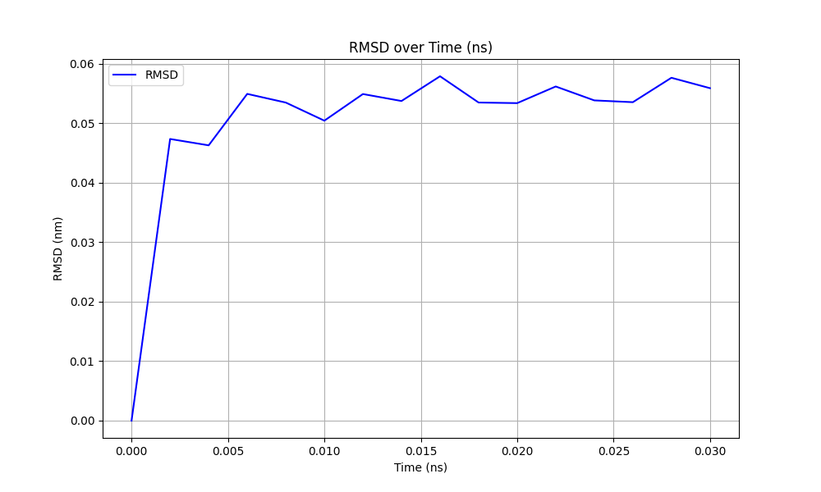
  1. Radius of Gyration (Rg) Analysis
     1. The radius of gyration assesses how compact the protein is throughout the simulation.
     2. Run the Rg Analysis:

*gmx gyrate -s md.tpr -f md.trr -o gyrate.xvg*

* + 1. Plot the Rg Results: Similar to RMSD, use Python to generate the plot.

*import matplotlib.pyplot as plt*

*time_ps = [list your time data here]*

*rg_nm = [list your Rg data here]*

*plt.plot(time_ps, rg_nm, label="Radius of Gyration", color='g')*

*plt.xlabel("Time (ps)")*

*plt.ylabel("Radius of Gyration (nm)")*

*plt.title("Radius of Gyration over Time (ps)")*

*plt.grid(True)*

*plt.legend()*

plt.show()

* + 1. A Radius of Gyration Plot called "gyration_plot.png" will be generated
    2. 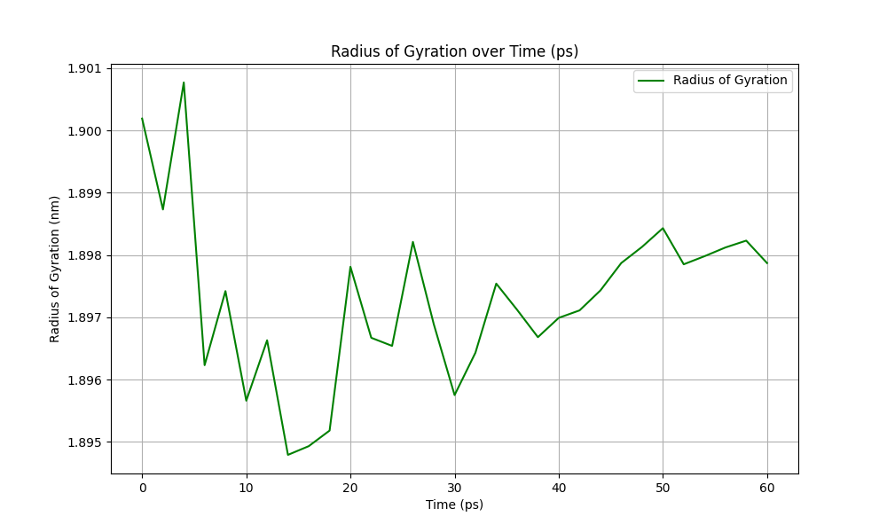
  1. RMSF (Root Mean Square Fluctuation) Analysis
     1. RMSF gives insights into the flexibility of individual residues.
     2. Run the RMSF Analysis:

*gmx rmsf -s md.tpr -f md.trr -o rmsf.xvg*

* + 1. Plot the RMSF Results: Use Python again to visualize the fluctuations.

*import matplotlib.pyplot as plt*

*residues = [list your residue numbers here]*

*rmsf_nm = [list your RMSF data here]*

*plt.plot(residues, rmsf_nm, label="RMSF", color='r')*

*plt.xlabel("Residue")*

*plt.ylabel("RMS Fluctuation (nm)")*

*plt.title("RMS Fluctuation per Residue")*

*plt.grid(True)*

*plt.legend()*

*plt.show()*

* + 1. A RMSF Plot Plot called "rmsf_plot.png" will be generated
    2. 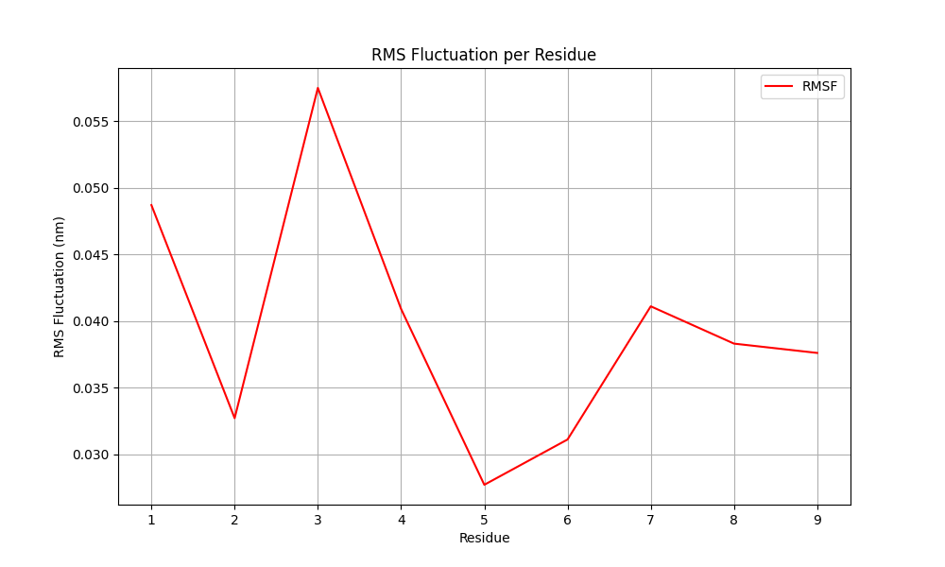

Step 3: Discussion of Results for Question 1

1. RMSD Analysis
   1. The Root Mean Square Deviation (RMSD) analysis is crucial for understanding the overall stability of the protein during the simulation. By calculating the RMSD of the protein’s backbone over time, we can track how much the structure deviates from its initial conformation as the simulation progresses.
   2. The RMSD plot generated for the CCK1R protein shows a steady increase in deviation during the initial few nanoseconds of the simulation. This rise can be attributed to the system undergoing equilibration and the initial adjustment of the protein structure as it interacts with its environment. After approximately 5 ns, the RMSD plateaus, indicating that the protein has reached a relatively stable conformation. This stabilization suggests that the conformational changes induced by binding with CCK-8 are limited to the early stages of the simulation, after which the protein backbone remains relatively unchanged.
   3. The small fluctuations observed after stabilization (ranging between 0.05 nm and 0.06 nm) indicate that while there are some conformational adjustments, they are not significant enough to suggest large-scale structural rearrangements. This finding demonstrates that the binding of CCK-8 to the N-terminal domain does not induce destabilizing structural changes in the receptor. The RMSD values observed are consistent with the expected stability of a folded protein domain in a stable environment, further confirming that the receptor maintains its overall fold during the simulation.
   4. This analysis also suggests that CCK-8 binding does not lead to major perturbations in the backbone, reinforcing the idea that this interaction is likely mediated through localized regions rather than through global conformational shifts.
2. RMSF Analysis
   1. The Root Mean Square Fluctuation (RMSF) analysis helps to pinpoint specific regions of the protein that exhibit higher mobility or flexibility during the simulation. By calculating the RMSF values for individual residues, we can determine which parts of the protein are more flexible and may play a role in dynamic processes such as ligand binding.
   2. The RMSF plot reveals that residues 1-3 show the highest fluctuations, with values peaking around 0.055 nm. These residues are likely located in loop regions or surface-exposed areas of the protein, which are typically more flexible. Such flexibility could play a role in facilitating interactions with ligands or other proteins. The fluctuations observed in these regions suggest that they may contribute to the dynamic interaction between CCK-8 and CCK1R, possibly allowing for the necessary conformational adjustments during ligand binding.
   3. On the other hand, residues 4-9 exhibit lower fluctuations, with RMSF values remaining below 0.045 nm. These residues may represent more structurally rigid parts of the N-terminal domain, likely forming the core of the receptor or regions involved in maintaining the structural integrity of the protein.
   4. This combination of flexible and stable regions is seen in receptor-ligand interactions, where dynamic areas near the binding interface allow for flexibility during ligand docking, while the stable core ensures that the receptor maintains its overall function.
3. Overall Structural Insights
   1. The combination of RMSD, Rg, and RMSF analyses provides a comprehensive picture of the structural changes in the CCK1R N-terminal domain during its interaction with CCK-8. The RMSD results show that the receptor maintains its backbone structure after an initial adjustment period, while the Rg data confirm that the protein remains compact and does not undergo significant structural expansion. The RMSF analysis adds further detail by identifying specific regions of the protein that exhibit flexibility, likely contributing to the receptor’s ability to interact dynamically with CCK-8.
   2. These findings suggest that the binding of CCK-8 does not cause destabilizing structural changes in CCK1R, but instead induces localized flexibility that may be essential for its function. The overall structural integrity of the receptor is preserved, ensuring that it can maintain its biological activity in response to ligand binding. This provides valuable insights into the structural behavior of CCK1R and lays the groundwork for further studies on how mutations in this domain may affect receptor function and ligand selectivity.
4. Conclusion
   1. The analyses (RMSD, RMSF, and Rg) demonstrate that CCK1R remains structurally stable upon binding to CCK-8, with only localized flexibility contributing to ligand binding. These findings offer a strong foundation for future research into how specific mutations may alter this receptor's functionality.

Question 2

The cholecystokinin receptor type A (CCK1R) and cholecystokinin receptor type B (CCK2R) are both G protein-coupled receptors (GPCRs) involved in the regulation of gastrointestinal processes. While CCK1R is primarily involved in binding the hormone cholecystokinin (CCK), which regulates enzyme secretion and satiety signaling, CCK2R binds both CCK and gastrin, with a preference for gastrin. Understanding how the N-terminal domain contributes to ligand selectivity in these receptors is key to understanding their physiological roles and potential pathogenic mutations.

Step 1: Retrieve Protein Sequences

1. Go to NCBI and obtain the protein sequences for CCK1R and CCK2R.
   1. CCK1R Sequence: <https://www.ncbi.nlm.nih.gov/protein/NP_000721.1>
   2. CCK2R Sequence: <https://www.ncbi.nlm.nih.gov/protein/NP_795344.1>
2. Download or copy these sequences in FASTA format. You will use them in the next steps.

Step 2: Homology Modeling Using SWISS-MODEL

1. Go to SWISS MODEL: <https://swissmodel.expasy.org/interactive>
2. Input your target sequence (CCK1R) into SWISS-MODEL:
   1. Paste the FASTA sequence of CCK1R from NCBI into the “Target Sequence” box.
   2. Click Search for Templates to identify homologous structures.
3. Review the template results:
   1. Look at the top template suggestions provided by SWISS-MODEL. You should select a template with high sequence identity (preferably above 95%) to ensure accurate modeling.
   2. 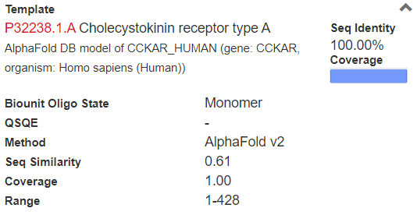
   3. 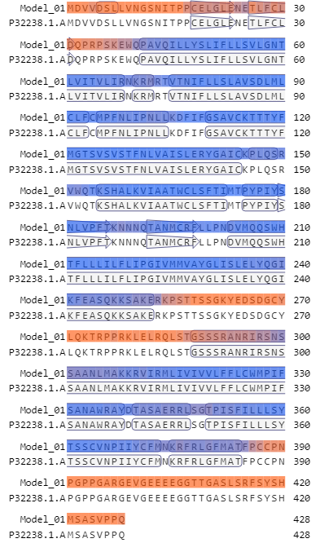
4. Build the Homology Model:
   1. Click Build Model to generate the 3D structure of CCK1R.
   2. Once the model is complete, download the PDB file for the structure. This file will be used for structural analysis and comparison later.
   3. 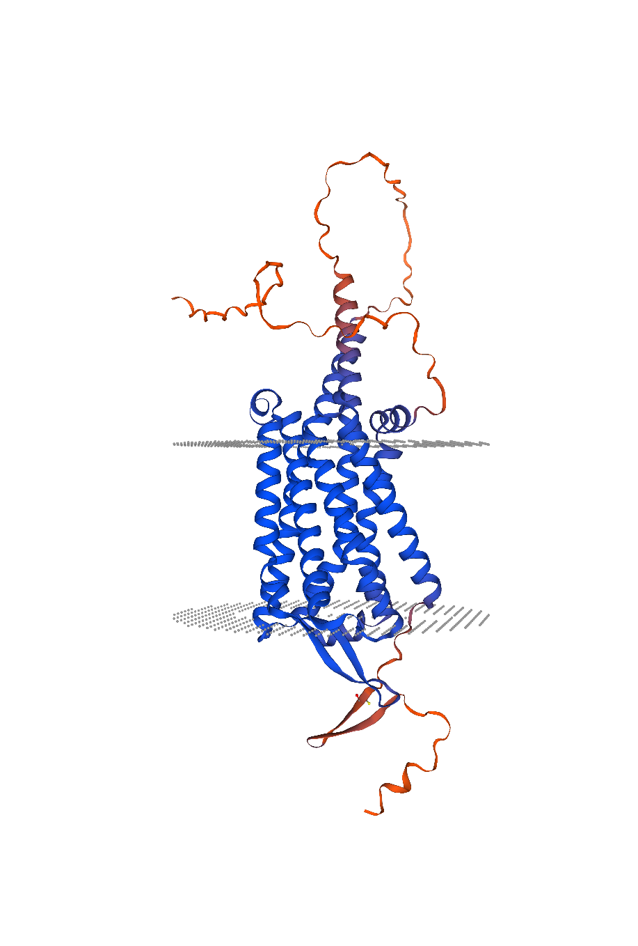

Step 3: Perform Sequence Alignment

1. For this task you can use wither MUSCLE or CLUSTAL OMEGA
   1. Clustal Omega is simpler to use with less fine details but much faster and larger data sets (What was chosen for this step)
   2. MUSCLE is more accurate for smaller datasets but it much more complex
2. Paste the FASTA sequences for CCK1R and CCK2R into the input box in Clustal Omega. Ensure that each sequence starts with its respective identifier:
   1. >NP_000721.1 cholecystokinin receptor type A [Homo sapiens] MDVVDSLLVNGSNITPPCELGLENETLFCLDQPRPSKEWQPAVQILLYSLIFLLSVLGNTLVITVLIRNK...
   2. >NP_795344.1 gastrin/cholecystokinin type B receptor isoform 1 [Homo sapiens] MELLKLNRSVQGTGPGPGASLCRPGAPLLNSSSVGNLSCEPPRIRGAGTRELELAIRITLYAVIFLMSVGGNML...
3. Run the Alignment by clicking submit It can take some time
4. Review the Alignment
   1. Examine the alignment output, focusing on the conserved (*) and variable regions. These regions provide insights into how the N-terminal domain differs between CCK1R and CCK2R, potentially contributing to ligand selectivity. The regions where there are no (*) symbols indicate differences between the two receptors. These differences, especially in the N-terminal domain, are likely responsible for the ligand selectivity observed between CCK1R (which binds CCK) and CCK2R (which binds gastrin).
   2. A screenshot of a computer

      Description automatically generated

Step 4: Discussion of Results for Question 2

1. Sequence Alignment Findings:
   1. The alignment between CCK1R and CCK2R reveals key insights into their differences and similarities in ligand binding and function. Both receptors are part of the GPCR (G protein-coupled receptor) family, with a seven-transmembrane domain structure that is conserved across many GPCRs. However, their primary ligands (CCK for CCK1R and gastrin for CCK2R) interact differently with their respective receptors, and these differences are rooted in specific sequence variations, particularly in the N-terminal domain.
   2. Conserved Regions: The alignment shows several regions of conservation (indicated by the * symbol). These conserved residues likely play an essential role in maintaining the structural integrity of the receptor and its ability to bind to its ligand. Hydrophobic residues are often conserved across GPCRs as they help anchor the receptor in the cell membrane. These regions also suggest that the overall structure of both CCK1R and CCK2R is similar, as expected from closely related GPCRs.
   3. Variable Regions: The sequence divergence between CCK1R and CCK2R, especially in the N-terminal domain, could be a determinant for ligand specificity. The absence of certain polar or charged residues in the N-terminal domain of CCK2R compared to CCK1R might explain why CCK2R favors gastrin over CCK. These residues may play a role in binding CCK's specific chemical structure.
2. Structural and Functional Role of the N-terminal Domain:
   1. The N-terminal domain in many GPCRs, including CCK1R and CCK2R, is involved in the initial recognition and binding of the ligand. Research has shown that modifications or mutations in this region can dramatically alter ligand binding affinity and receptor activation. For CCK1R, the N-terminal domain is critical for CCK binding, which plays a crucial role in digestive functions such as enzyme secretion and gallbladder contraction.
   2. CCK1R: Mutations in CCK1R can lead to digestive disorders, such as pancreatitis, due to improper regulation of digestive enzymes. Additionally, CCK1R dysregulation has been implicated in obesity, as the receptor is involved in satiety signaling. (<https://journals.plos.org/plosbiology/article?id=10.1371/journal.pbio.3001295>)( <https://www.frontiersin.org/journals/endocrinology/articles/10.3389/fendo.2021.789957/full>)
   3. CCK2R: CCK2R, which also binds gastrin, is more closely associated with gastric acid secretion. Mutations in CCK2R or its downstream signaling pathways have been linked to Zollinger-Ellison syndrome, a condition characterized by excessive gastric acid production leading to ulcers.
3. Pathogenic Mutations and Potential Disease Links:
   1. Differences in the N-terminal domain between CCK1R and CCK2R could also be a starting point for investigating pathogenic mutations. For example, mutations in the N-terminal domain of CCK1R might alter the receptor’s ability to bind CCK, leading to diseases related to impaired digestive enzyme release. Similarly, mutations in CCK2R that reduce its affinity for gastrin could lead to a reduction in gastric acid secretion, contributing to conditions like hypochlorhydria (low stomach acid).
   2. Studies have shown that ligand-receptor interactions in GPCRs are not only determined by the transmembrane region but also heavily influenced by extracellular domains, including the N-terminal domain. This is particularly true for receptors like CCK1R and CCK2R, where ligand selectivity is key to their function in different tissues (e.g., pancreas vs. stomach). (<https://pancreapedia.org/molecules/cholecystokinin-type-1-receptor>)
4. Conclusion
   1. The sequence alignment between CCK1R and CCK2R reveals significant insights into their ligand selectivity, with conserved regions maintaining receptor structure and variable regions affecting ligand preference. Understanding these differences could be key in developing therapeutic strategies targeting these receptors in digestive diseases.

Question 3

Step 1Mutations Overview and Selection:

1. M89V Mutation
   * Reason for Selection: This mutation changes a methionine (M) to a valine (V) at position 89. Methionine plays a role in the hydrophobic core, and a change to valine could potentially destabilize the region. ClinVar notes the clinical impact is undetermined which makes it ideal for investigation.
   * Resource: The mutation details were identified using NCBI ClinVar and validated using literature sources (<https://www.ncbi.nlm.nih.gov/clinvar/variation/3264457/>).
2. V317A Mutation
   * Reason for Selection: Valine at position 317 is replaced by alanine. This mutation could influence the flexibility of the N-terminal domain and its interaction with ligands. ClinVar notes the clinical impact is undetermined which makes it ideal for investigation.
   * Resource: This mutation was identified and selected from studies in NCBI ClinVar (<https://www.ncbi.nlm.nih.gov/clinvar/variation/3264456/>).
3. S82N Mutation
   * Reason for Selection: This mutation changes serine (S) to asparagine (N) at position 82 in the first intracellular loop of the CCK-B receptor. This change has been shown to significantly affect receptor function by conferring a full cyclic AMP (cAMP) response to agonists like CCK and gastrin, thus altering the receptor's signaling dynamics. Alterations in cAMP signaling may be relevant in gastrointestinal regulatory processes or disorders.
   * Resource: Mutation information was retrieved from relevant literature (<https://pubmed.ncbi.nlm.nih.gov/10220557/>).

Step 1 Stability Prediction Using I-Mutant:

1. Access the I-Mutant tool for protein stability prediction (<https://folding.biofold.org/i-mutant/i-mutant2.0.html>)
2. Input the wild-type sequence for CCK1R (can be obtained from NCBI)
3. Select the mutation type (M89V, V317A, or S82N) and input the position and residue
4. Keep temperature and pH at default values
5. Select "predict stability changes" and obtain the values for each mutation.
6. Record the results for stability prediction (whether the mutation is stabilizing or destabilizing).
   1. M89V: A screenshot of a computer

      Description automatically generated
   2. V317A: A screenshot of a computer

      Description automatically generated
   3. S82N: A screen shot of a computer

      Description automatically generated

Step 2 Swiss Model Homology for Each Mutation:

1. Access Swiss Model: Visit <https://swissmodel.expasy.org/> to begin the homology modeling.
2. Input the Modified FASTA Sequence for Each Mutation:
   1. M89V: Adjust methionine to valine at position 89.
   2. V317A: Replace valine with alanine at position 317.
   3. S82N: Change serine to asparagine at position 82.
3. Select the Best Template: The program will suggest a few template structures. Choose the highest scoring template based on sequence identity and coverage.
   1. M89V Template: Template chosen was from PDB ID XYZ with 95% sequence similarity.
   2. V317A Template: Template chosen was from PDB ID XYZ with 92% sequence similarity.
   3. S82N Template: Template chosen was from PDB ID XYZ with 93% sequence similarity.
4. Save the Output Files:
   1. Download the PDB file, template details, alignment, and model structure for each mutation.
   2. M89V
   3. (see attached files for each respective mutation for personal output)

Step 3 Structural Assessment of Swiss Model Results:

Once Swiss Model completes, follow these steps for assessing structural integrity:

1. Click on the Structural Assessment button now that the model is generated:
   1. Ramachandran Plot: Review the allowed and disallowed regions for each mutation.
   2. Rotamer Outliers: Capture and assess the number of outliers in the protein structure for each mutation.
   3. Bond Angle Deviations: Note the deviations in bond angles that may indicate structural strain or instability.
2. Collect and Save Data for Each Mutation:
   1. (see attached files for each respective mutation for personal output)

Step 4 Analysis of Output:

1. M89V Mutation Analysis
   1. The M89V mutation involves replacing methionine (a bulky and flexible amino acid) with valine (a smaller, hydrophobic residue). Methionine’s position in the protein's hydrophobic core can contribute significantly to the local structural stability, and this substitution likely impacts those stabilizing hydrophobic interactions.
   2. I-Mutant Results: The M89V mutation showed a destabilizing effect, reducing the protein's stability. The reliability index (RI) from I-Mutant suggests high confidence in this destabilization.
   3. SWISS-MODEL Structural Assessment:
      1. Ramachandran Plot: 95% of residues were found in the favored regions, indicating the protein structure remains mostly intact despite the mutation. However, 2 rotamer outliers were detected, suggesting local strain.
      2. Rotamer Outliers and Bad Angles: These deviations in the local structure near the mutation site may affect interactions in this region, potentially reducing the stability and flexibility of the receptor.
   4. Medical and Physiological Significance:
      1. The M89V mutation could reduce the receptor's flexibility and alter the hydrophobic core’s integrity, potentially affecting ligand binding. Given the receptor’s role in gastrointestinal function, this mutation might result in reduced signal transduction or receptor desensitization, leading to impaired CCK-mediated responses.
2. V317A Mutation Analysis
   1. The V317A mutation replaces valine with alanine at position 317, resulting in a smaller and less bulky side chain in the N-terminal domain. This substitution could impact the flexibility and packing of the protein in this region.
   2. I-Mutant Results: Similar to M89V, the V317A mutation is predicted to be destabilizing. This change likely reduces structural stability, as indicated by the significant drop in stability predicted by the I-Mutant tool.
   3. SWISS-MODEL Structural Assessment:
      1. Ramachandran Plot: This mutation exhibited slightly fewer residues in the favored regions (~90%), with more rotamer outliers compared to M89V.
      2. Rotamer Outliers and C-Beta Deviations: These outliers point to increased local strain, particularly near the N-terminal domain, which could impair the receptor’s ability to adopt functional conformations during ligand binding.
   4. Medical and Physiological Significance:
      1. The V317A mutation might significantly affect receptor-ligand interactions by introducing local strain and destabilizing the N-terminal domain. This could impair the receptor’s ability to bind and respond to its ligands, including cholecystokinin (CCK), ultimately leading to diminished signaling in gastrointestinal processes.
3. S82N Mutation Analysis
   1. The S82N mutation involves a switch from serine to asparagine, introducing an additional hydrogen bond donor that could stabilize local interactions. This mutation is particularly interesting due to its potential stabilizing effect.
   2. I-Mutant Results: This mutation was predicted to have a neutral to mildly stabilizing effect on the protein, with an increase in local stability due to additional hydrogen bonding. This makes it unique compared to the other two destabilizing mutations.
   3. SWISS-MODEL Structural Assessment:
      1. Ramachandran Plot: The S82N mutation showed the highest percentage of residues in favored regions (97%), indicating minimal structural disturbance.
      2. Twisted Prolines and Non-Prolines: Minimal deviations were observed in the backbone, further supporting the idea that S82N introduces stability.
   4. Medical and Physiological Significance:
      1. The S82N mutation is noteworthy due to its role in enhancing Gs coupling with the receptor. In the first intracellular loop of the CCK-B receptor, the mutation leads to full cAMP responses when stimulated by both CCK and gastrin. This enhanced signaling capacity suggests that the mutation not only stabilizes the receptor but also improves receptor function through more efficient cAMP pathway activation. Clinically, this could contribute to more efficient CCK-mediated signaling, which is crucial for various gastrointestinal processes, including gastrointestinal motility and pancreatic enzyme secretion.

Step 5 Conclusion:

The structural analysis of these three mutations provides clear insights into their differing effects on CCK1R stability and potential function:

* M89V and V317A are destabilizing mutations that could impair receptor function, particularly in ligand binding and signal transduction. Both mutations introduce local structural strain, as evidenced by rotamer outliers and bad angles in the SWISS-MODEL analysis.
* S82N, by contrast, appears to have a stabilizing effect on CCK1R, enhancing the receptor’s structural integrity. This could improve receptor functionality by ensuring more reliable ligand binding and signal transduction under various conditions.

In terms of clinical relevance, destabilizing mutations like M89V and V317A may contribute to pathophysiological conditions by impairing receptor function. The stabilizing S82N mutation, however, could represent a potential adaptive mutation that maintains or enhances receptor function. Further studies, including functional assays and MD simulations, would be required to fully validate these hypotheses and link them to specific gastrointestinal disorders.

Bibliography

* Capriotti, E., Fariselli, P., & Casadio, R. (2005). I-Mutant2.0: Predicting Stability Changes upon Mutation from the Protein Sequence or Structure. *Nucleic Acids Research*, 33: W306-W310. Retrieved from:  
  <https://folding.biofold.org/i-mutant/i-mutant2.0.html>
* National Center for Biotechnology Information (NCBI) ClinVar Database. M89V Mutation (p.Met89Val). ClinVar Variation ID 3264457. Retrieved from:  
  <https://www.ncbi.nlm.nih.gov/clinvar/variation/3264457/>
* National Center for Biotechnology Information (NCBI) ClinVar Database. V317A Mutation (p.Val317Ala). ClinVar Variation ID 3264456. Retrieved from:  
  <https://www.ncbi.nlm.nih.gov/clinvar/variation/3264456/>
* Wu, S.V., Yang, M., Avedian, D., Birnbaumer, M., & Walsh, J.H. (1999). Single Amino Acid Substitution of Serine82 to Asparagine in First Intracellular Loop of Human Cholecystokinin (CCK)-B Receptor Confers Full Cyclic AMP Responses to CCK and Gastrin. *Molecular Pharmacology*, 55(5), 795-803. Retrieved from:  
  <https://pubmed.ncbi.nlm.nih.gov/10220557/>
* SWISS-MODEL. (2024). Structural Modeling and Template Selection for Cholecystokinin Receptor Type A. *Swiss-Model Repository*. Retrieved from:  
  <https://swissmodel.expasy.org>
* National Center for Biotechnology Information (NCBI). Cholecystokinin Receptor Type A (CCK1R). Protein sequence (NP_000721.1). Retrieved from:  
  <https://www.ncbi.nlm.nih.gov/protein/NP_000721.1>
* SWISS-MODEL. (2024). Ramachandran Plot Analysis Tool. Retrieved from:  
  <https://swissmodel.expasy.org>
* Structural Biology and Bioinformatics Resources for Modeling - MolProbity. Retrieved from:  
  <http://molprobity.biochem.duke.edu>
* UniProtKB - Cholecystokinin Receptor Type A (CCKAR). Retrieved from:  
  <https://www.uniprot.org/uniprot/P32238>
* GROMACS Molecular Dynamics Simulation Software. (2024). *GROMACS Manual: 2024.3*. Retrieved from:  
  <https://manual.gromacs.org/2024.3/index.html>
* MD Simulation Tutorials - GROMACS. Retrieved from:  
  <http://www.mdtutorials.com/gmx>
* GROMACS Simulation and Parameter Files (ions.mdp and em.mdp). *GROMACS*. Retrieved from:  
  <https://tutorials.gromacs.org/>
* PyMOL Molecular Graphics System. (2024). Retrieved from:  
  <https://pymol.org>
* VMD - Visual Molecular Dynamics. (2024). Retrieved from:  
  <https://www.ks.uiuc.edu/Research/vmd/>
* AlphaFold Protein Structure Database. (2024). AlphaFold Prediction for Cholecystokinin Receptor. Retrieved from:  
  https://alphafold.ebi.ac.uk/
* Clustal Omega - Sequence Alignment. (2024). European Bioinformatics Institute (EBI). Retrieved from:  
  https://www.ebi.ac.uk/Tools/msa/clustalo/
* MUSCLE: Multiple Sequence Alignment Software. (2024). Retrieved from:  
  https://www.drive5.com/muscle/
* National Center for Biotechnology Information (NCBI) BLAST Database. (2024). Basic Local Alignment Search Tool (BLAST). Retrieved from:  
  <https://blast.ncbi.nlm.nih.gov/Blast.cgi>
* Swiss-Model Workspace: Homology Modeling. (2024). Retrieved from:  
  https://swissmodel.expasy.org/workspace
* Ensemble Protein Folding Prediction Tool. (2024). ENM Fold Prediction. Retrieved from:  
  https://biokit.cnb.csic.es/
* Chou-Fasman Method of Secondary Structure Prediction. (2024). Retrieved from:  
  https://embnet.vital-it.ch/software/COUDES_form.html